**Assembly Report**

|  |  |
| --- | --- |
| Abdelrahman Hussein Mohammed | G5 |
| Khaled Hany AbdElGhafar | G5 |

Github repository link:

<https://github.com/Khaledhany28/Calculator-application-using-assembly>

Purpose of the Program:

This assembly program simulates a Calculator that add, subtract, multiply and divide the numbers

1.Massages to display:

Some massages that will appear to the user when he run the program.



2.Main Function:

Display the main massages to the User and call the other functions.

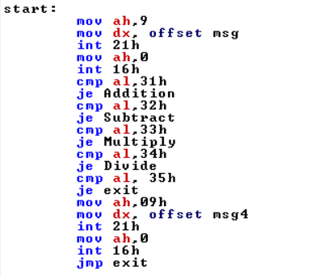

3. Addition:

Add the numbers and also it call other functions to handle the numbers

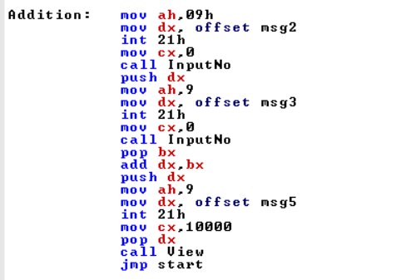

4. Multiplication:

Multiply the numbers and also it call other functions to handle the numbers

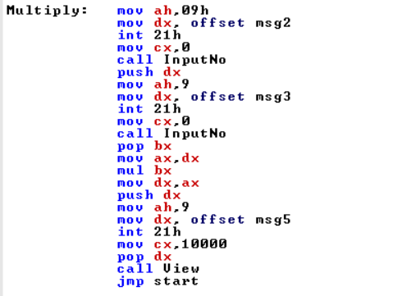

5. Subtract:

Subtract the numbers and also it call other functions to handle the numbers

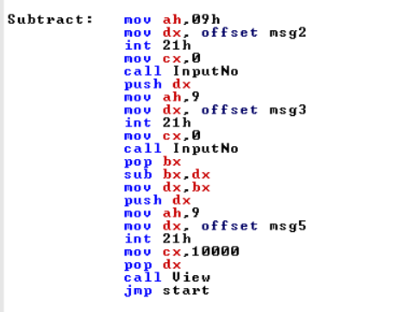

6.Divide:

Divide the numbers and also it call other functions to handle the numbers

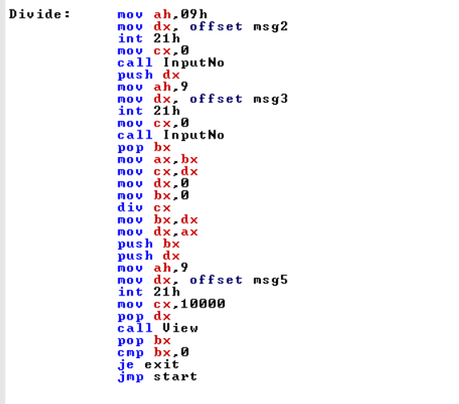

7.Input number:

Take digits from user to do the condition on it then it send it to form number when it end.

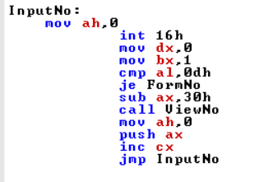

8.Form number:

Combines digits popped from the stack to form a full number.

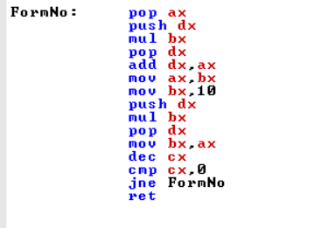

9.View numbers:

Display numbers on the screen.

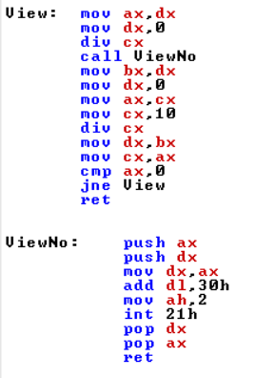

10.Exit:

To end the program you need to press 5.

